**DATA STRUCTURES/DATA INPUT**

**Database**

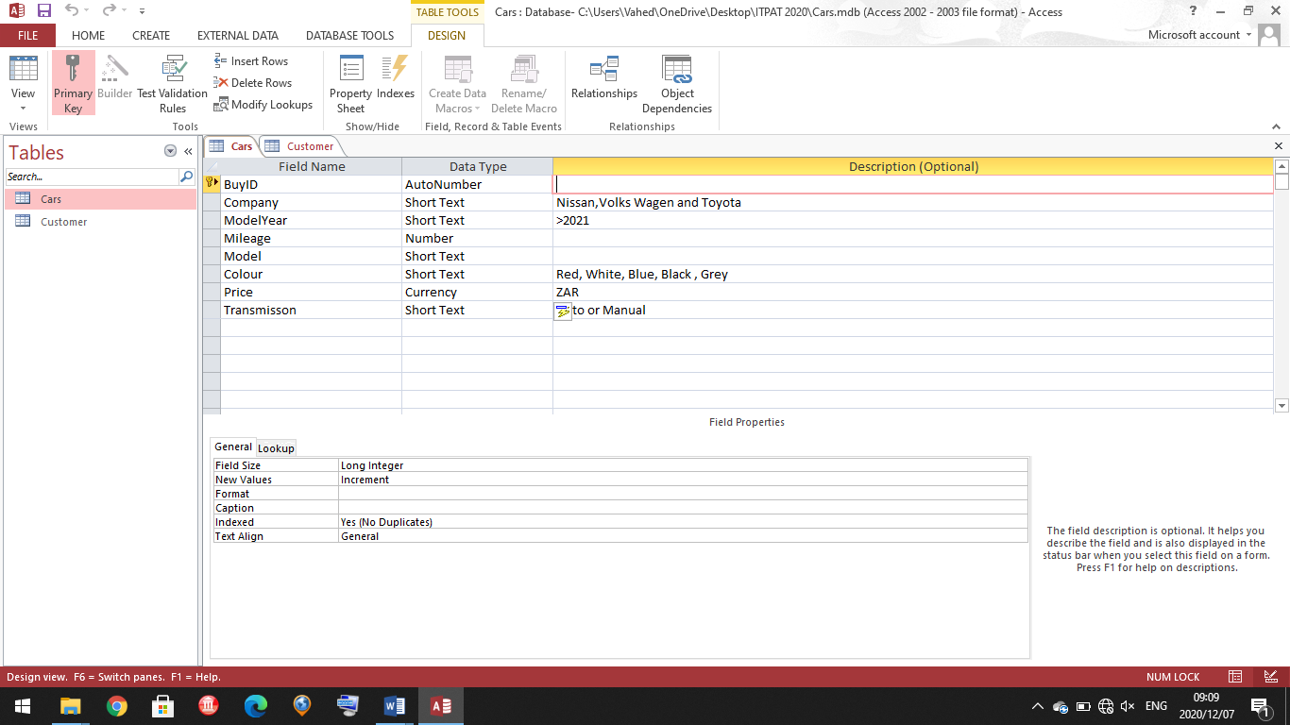**Table Cars**

**Table Cars**

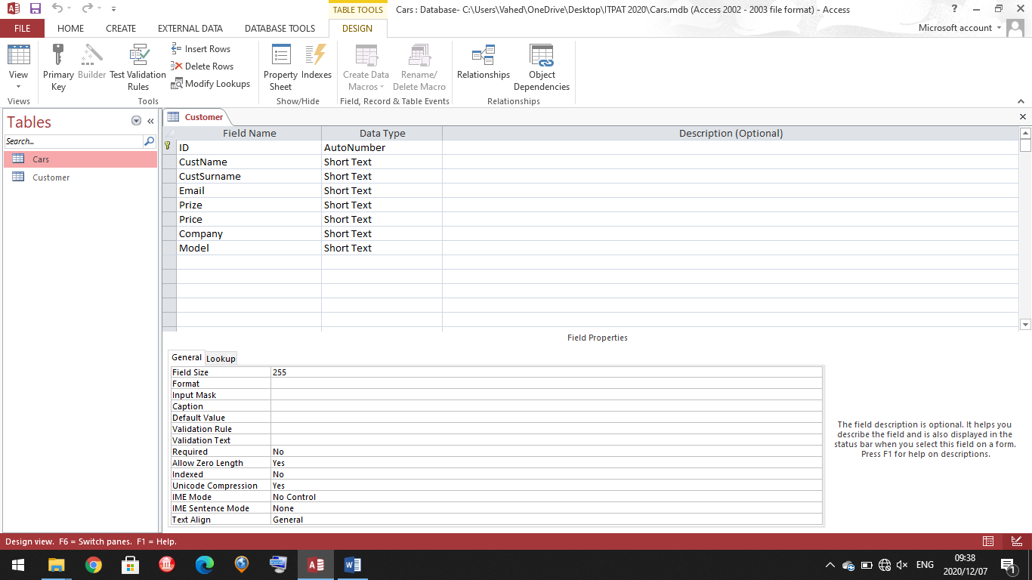

The user will be able to search through the database to find the car that suits him best. They can then order that car and their name will be added to the text file. A brief summary of the purchase will be displayed and the total after commission. Thereafter the listing will be removed.